1. **Purpose**

The purpose of this document is to provide guidelines for the creation of, and naming conventions to be used for, user stories, defects, and tasks in Rally.

**2.0 Scope**

The guidelines described herein apply to products and internal components produced by the Precision Cooling Global Control () Group. This includes but is not limited to:

* Test and production releases of iCOM applications
* Internal releases of SDK/Framework packages
* Auxiliary board firmware releases
* Hardware releases

These guidelines apply to all of the above that use the Rally tool to manage product development. This document assumes that the reader has a basic knowledge of working in Rally and the general structure of products under ‘Precision Cooling’ within Rally.

1. **Definitions**

The following definitions apply to work products outlined in the Rally tool:

* User story – A requirement for a feature or function that will be developed as part of a product development project. A requirement can be entered by the Product Marketing, Engineering, or Service groups. In Rally, a user story is given the reference designator of REQ. In common practice within PCGC, user stories are referred to as requirements.
* Parent requirement – The top level requirement for a given function or feature.
* Child requirement – A requirement that resides under a parent requirement. A given parent requirement may have several child requirements. Child requirements may have child requirements as well.
* Defect – A deficiency in a given work product (documentation, code, hardware, ect.) that causes that work product to not meet its required function or behavior. In Rally, defects carry the reference designator DEF. As a general rule, defects are linked to a given requirement.
* Defect Suite – Analogous to a parent / child requirement relationship. The practice within PCGC is to use a defect suite when there is a common defect across multiple projects or products. In Rally, defect suites carry the reference designator DS. The defect suite is the parent and is linked to individual defects in all applicable projects / products.
* Task – The lowest level in Rally. All requirements and defects are decomposed into tasks. The tasks contains, as a minimum, the description of the specific work item to be performed, the resource assigned to perform the work, and the estimated hours needed to complete the work. In Rally, tasks have the reference designator TSK.
* Project – In Rally, the project is the parent folder for all the REQs (and their associated TSKs and DEFs) for a given PCGC development project
* Release – A release is a subfolder under a project. A given project will have at least one release
* Iteration – An iteration is a folder that resides under a release; a release is made up of multiple iterations. An iteration defines a period of time (from one to several weeks) where a given set of REQs and DEFs are implemented and how work products are scheduled in Rally. A REQ or DEF cannot span multiple iterations. If all the work in a given REQ / DEF cannot be completed during a single iteration, the iteration must be lengthened to allow enough time to complete the REQ / DEF or the REQ / DEF must be split into a parent / child relationship to define what specific work (TSKs) will be completed in a given iteration. For the purposes of software development, an iteration culminates with the delivery of a software build suitable for bench / system test, field trial, or final product release.

1. **Instructions**

**Creating a new REQ / DEF**

All new REQs or DEFs should be created using the templates that reside in Rally. These templates contain a standard set of TSKs that will need to be performed to complete the desired feature / functionality outlined in the REQ or the correction needed as outlined in the DEF. To create the new REQ / DEF, perform the following steps:

In Rally, select the ‘Rally Process Practice Project

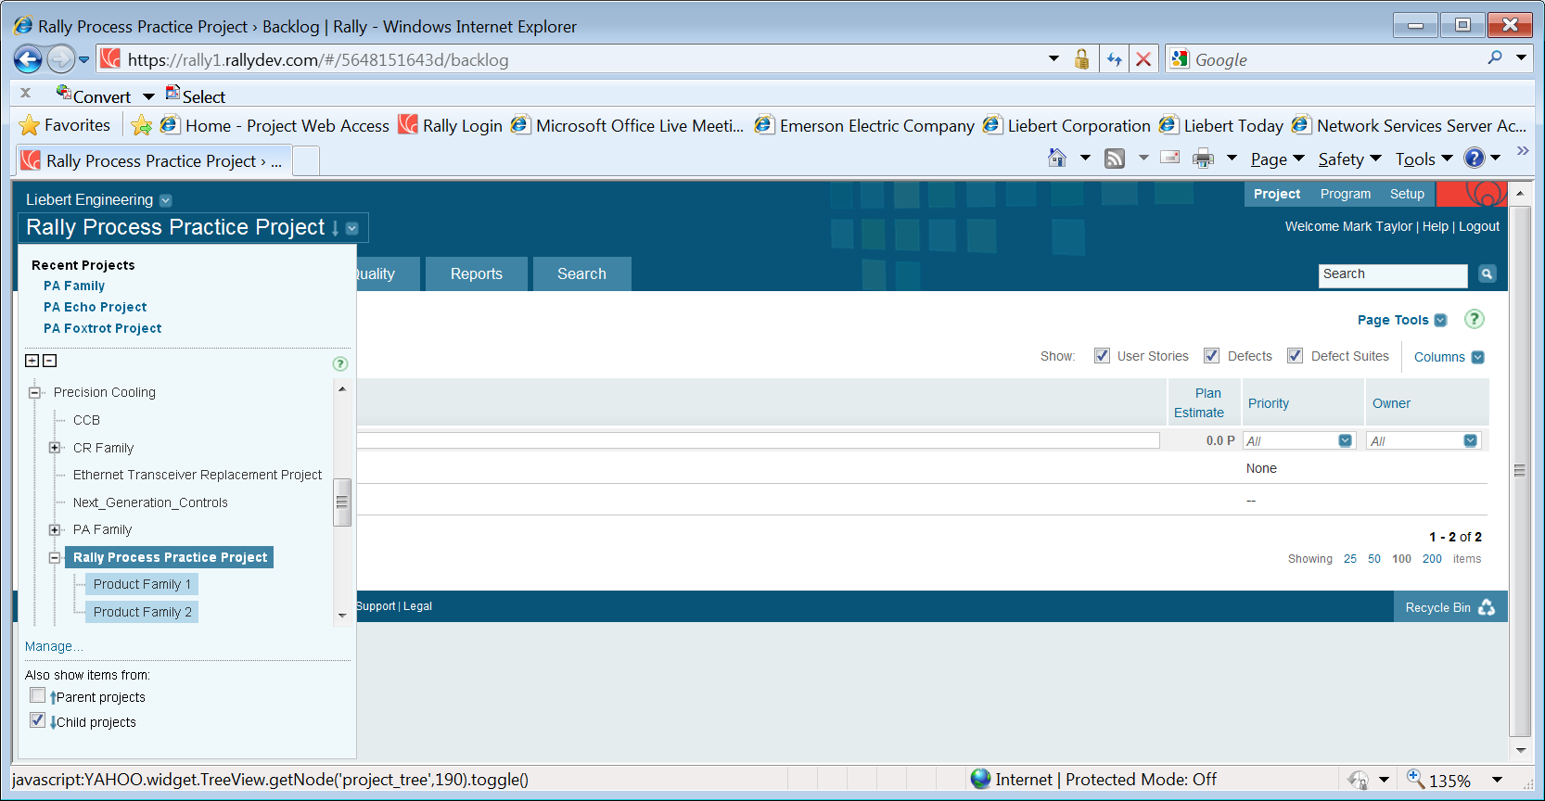

Select the Plan -> Backlog tab

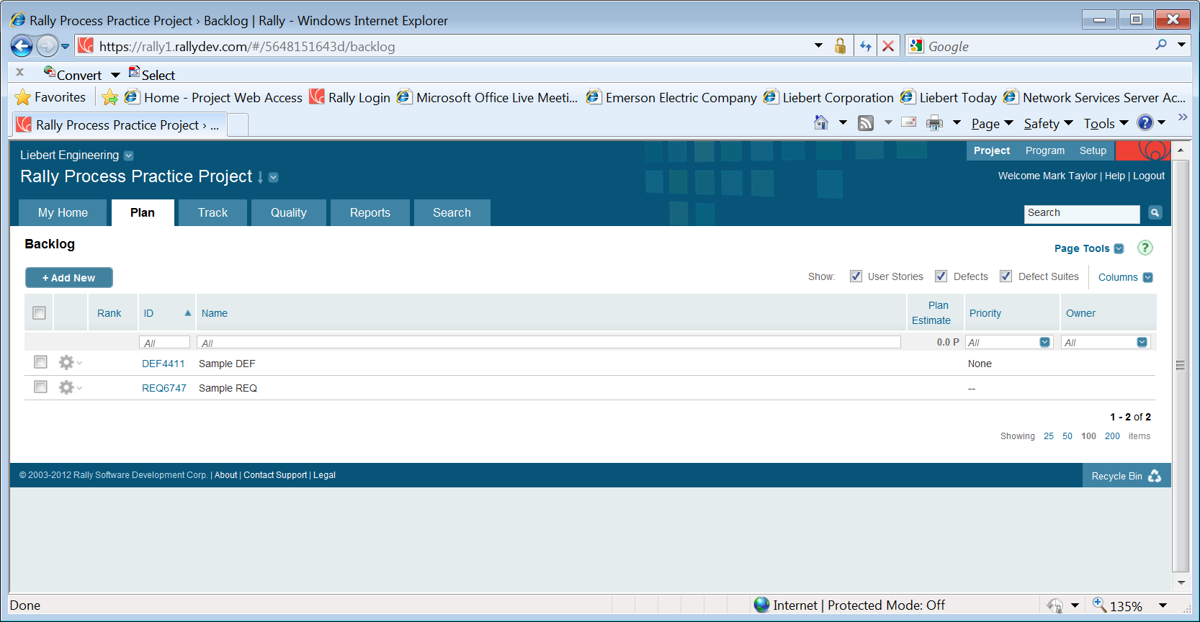

To create a REQ, click on REQ6747. Notice that there are six pre-defined TSKs for this REQ.

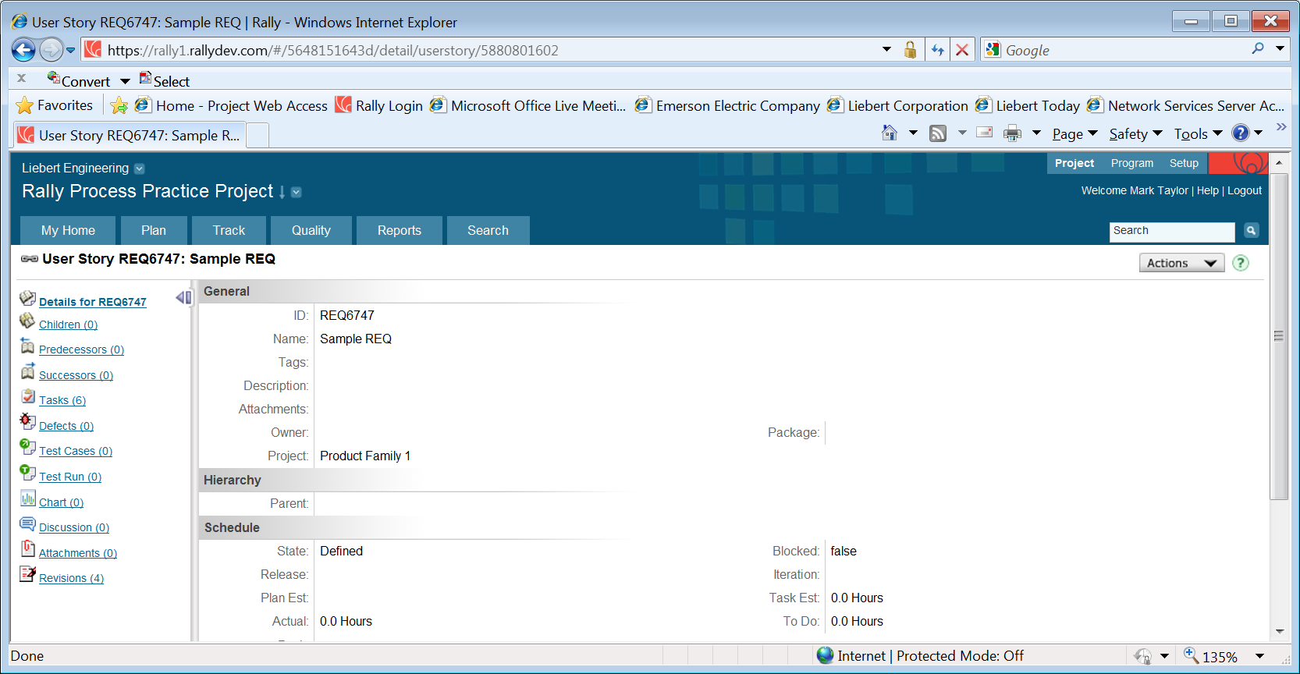

To create the new REQ, click on ‘Actions -> Copy’ in the upper right

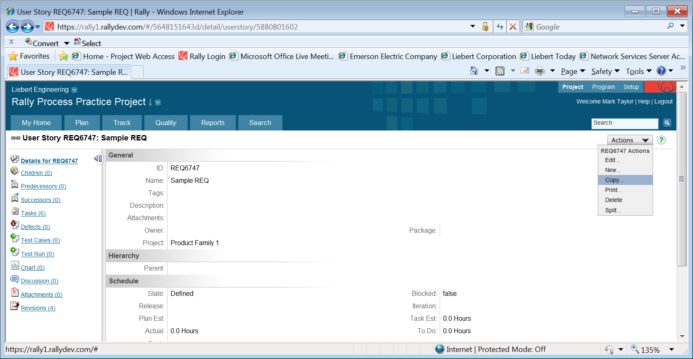

This will open up the following view in a new window.

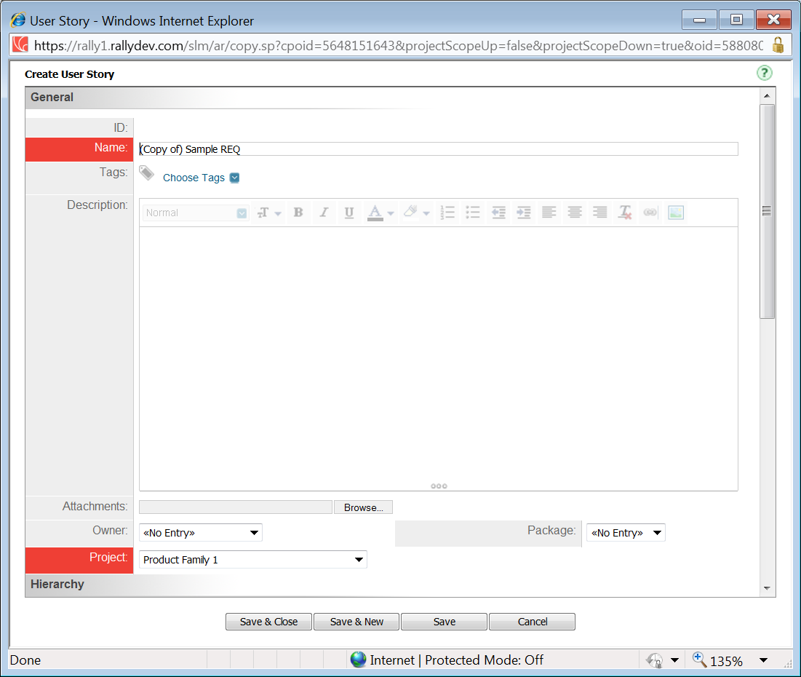

Change the name of the REQ to describe the desired function or feature.

If the new REQ is a change / addition to a current project, perform the following steps.

Under the ‘Tags’ field, select the ‘Cooling CCB’ tag and click ‘Apply’

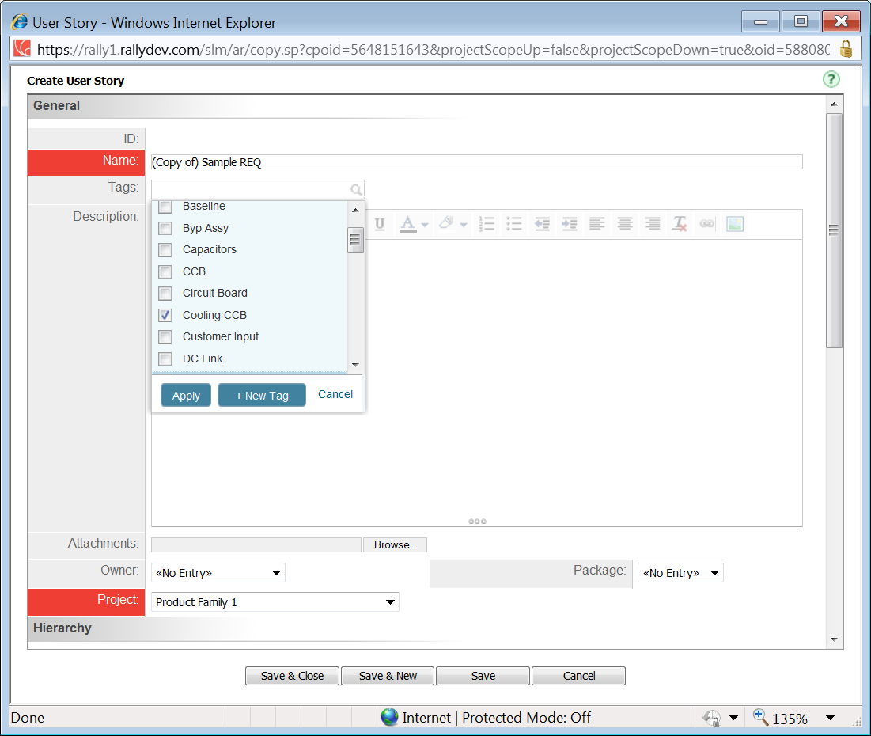

Enter a description for the REQ. State the description as a business need, problem statement, or desired feature / function. Describe ‘what’ needs to be changed / added, not ‘how’ it is to be implemented. The description must be clear enough to generate a development specification – ‘how’ the REQ will be met. The description must also be clear enough so that the REQ can be verified. The CCB will review the REQ to ensure that the description meets these guidelines.

Attach any documents that are needed to describe the REQ

Under ‘Owner’, assign the REQ to ‘Craig Ward’

Under ‘Project’, select ‘CCB’

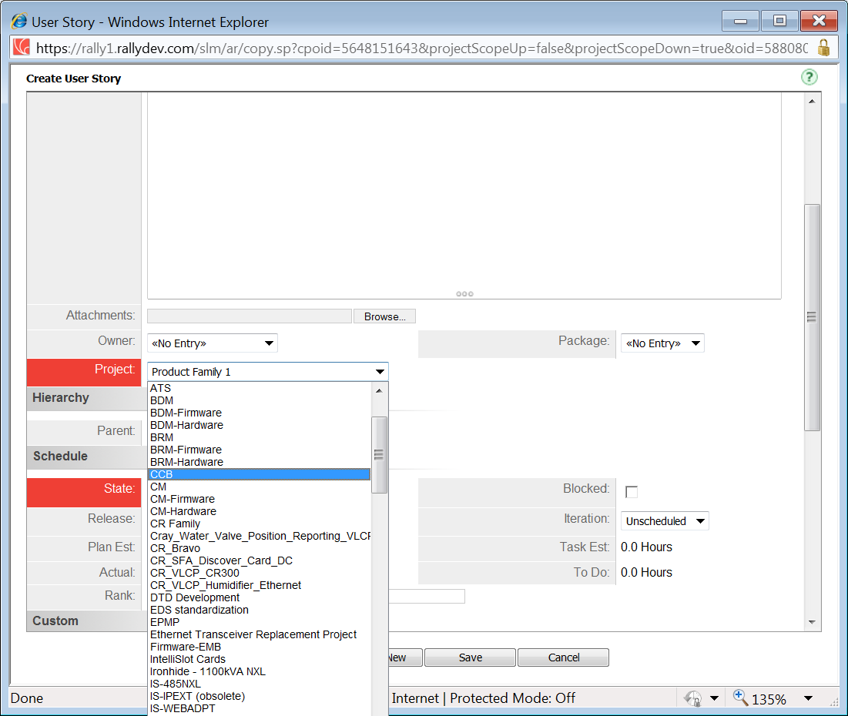

Once the fields have been entered, click ‘Save and Close’. The new REQ will be viewable in the ‘My Home -> CCB’ tab.

If the new REQ is being entered for a new project, the following will apply:

No tag will need to be selected unless directed by the project manager or project lead

The ‘Owner’ should be set to the product manager for the new project

The ‘Project’ should be set to the new project instead of ‘CCB’

Once ‘Save and Close’ has been clicked, the new REQ will appear in the ‘Plan -> Backlog’ tab of the new project

To create a defect, click on DEF4411 from the ‘Plan ->Backlog’ view. Click on ‘Actions->Copy’ in the upper right. Fill out the fields for the DEF in the same manner as for creating a new REQ.

The following items need to be noted:

If the new DEF is associated with an existing REQ:

Set the ‘Owner’ to the project lead

Set the ‘Project’ to the appropriate project associated with the REQ

Click on the ‘User Story’ magnifying glass and select the appropriate REQ that is associated to the new DEF

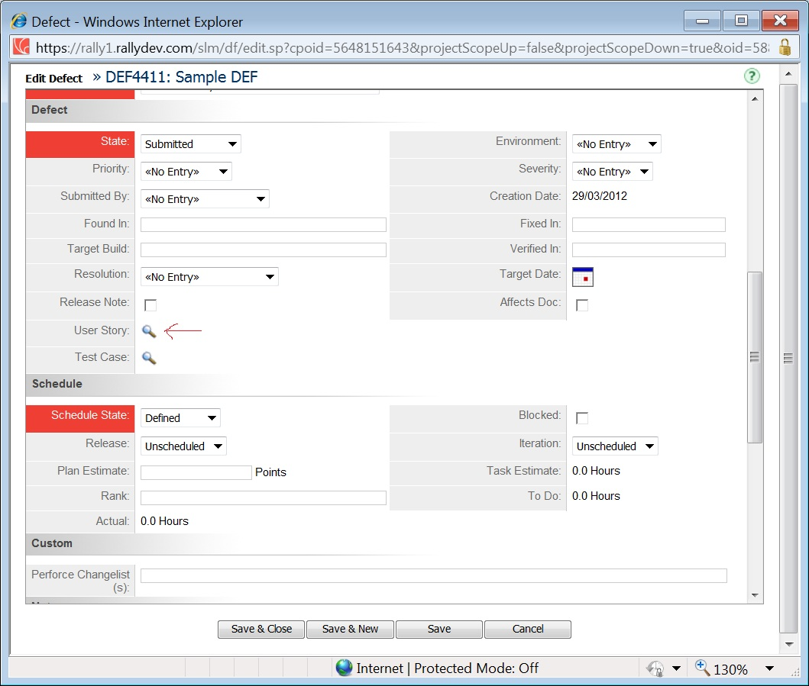

A window will pop up. Type in the number of the REQ or find it by entering a keyword to search.

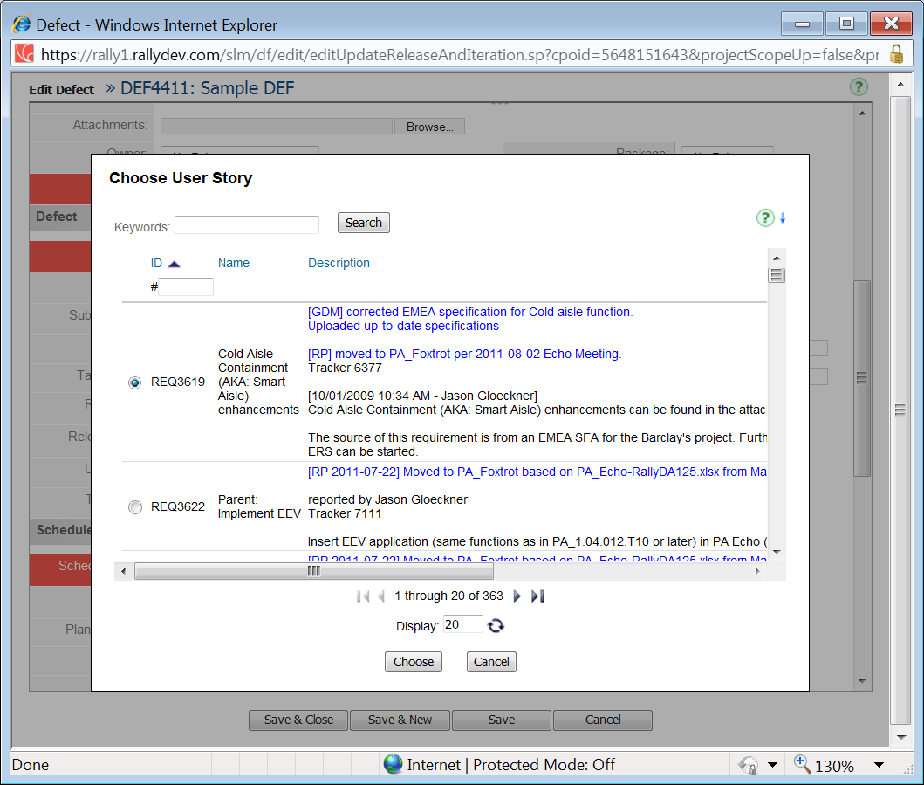

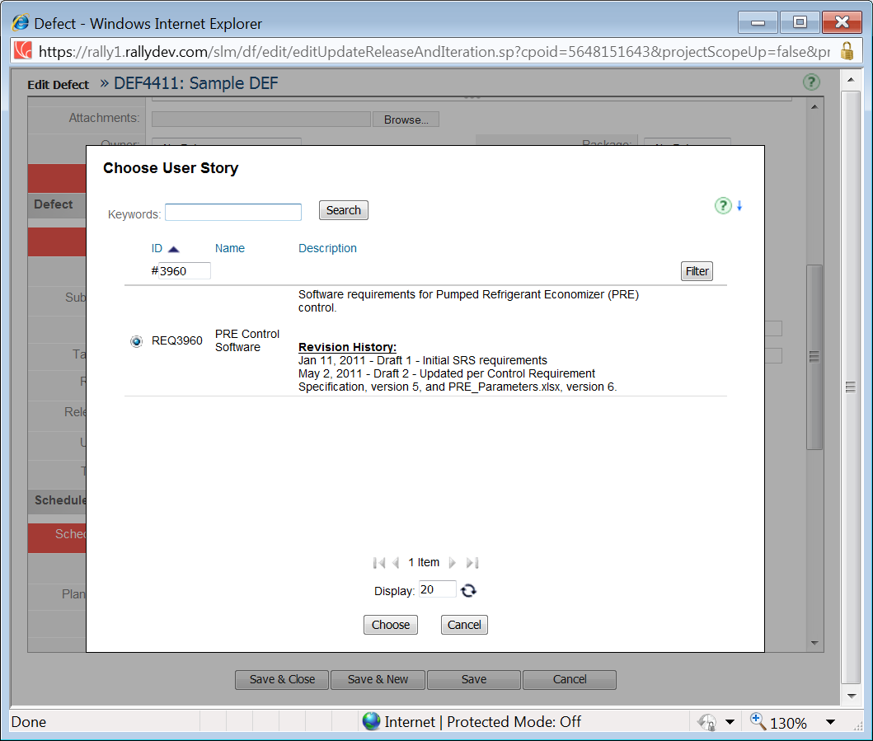

Once the appropriate REQ is selected, click ‘Choose’. The REQ will appear in the DEF Edit window.

The project manager / lead must ensure that the appropriate ‘Priority’ and ‘Severity’ fields are set for the DEF. The project manager / lead will schedule the DEF for the appropriate iteration where it will be fixed.

Click on ‘Save and Close’. The DEF will now appear in the project’s ‘Quality -> Defects’ view.

To view the list of project defects, click in the ‘Quality -> Defects’ tab from the desired project.

In the upper left of that page, select the ‘Defects View’ from the ‘View’ dropdown.

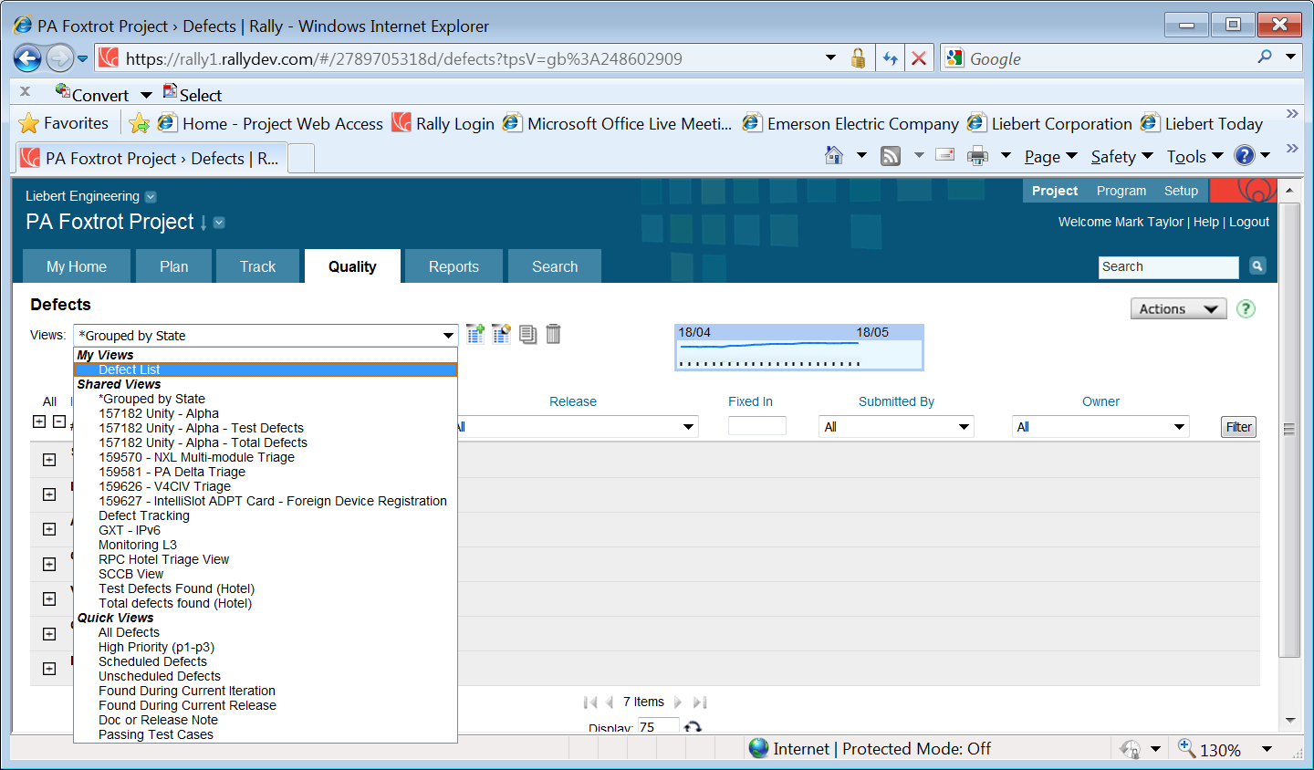

This brings up the standard project defect view.

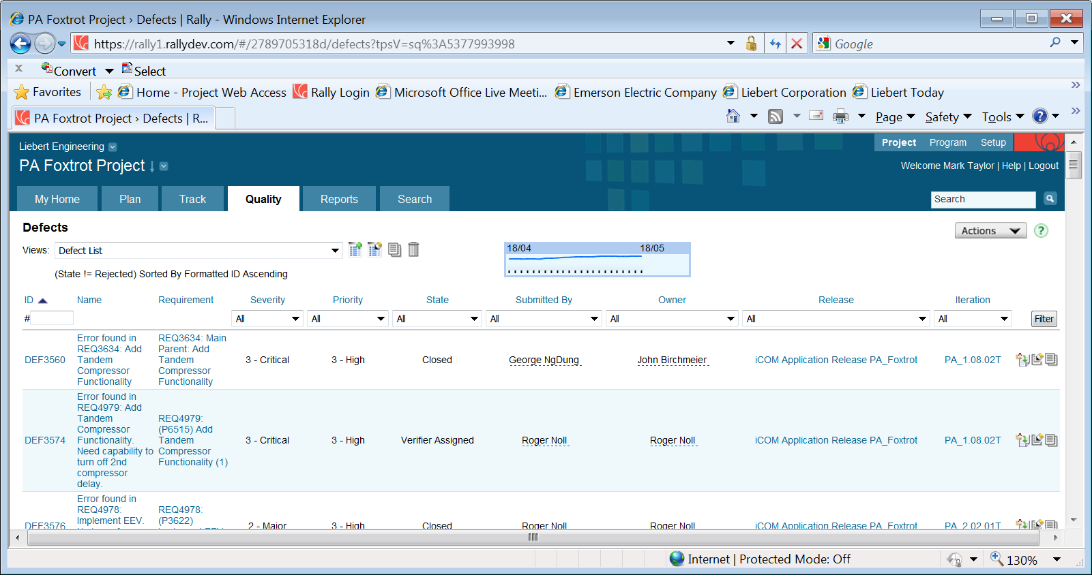

If the DEF is not associated with an existing REQ, fill out the DEF form with the necessary fields to assign it to the CCB as follows:

Assign the ‘Cooling CCB’ tag, ‘Craig Ward’ as the owner, and set the project to ‘CCB’.

Fill in the remaining items in the defect form as described above.

The new DEF will appear in the ‘My Home -> CCB’ view.

The CCB will review and update the ‘Priority’ and ‘Severity’ fields as needed.

**Task Naming Conventions**

To view the pre-defined TSKs, click on ‘Tasks (6)’ in the left pane of the REQ or DEF.

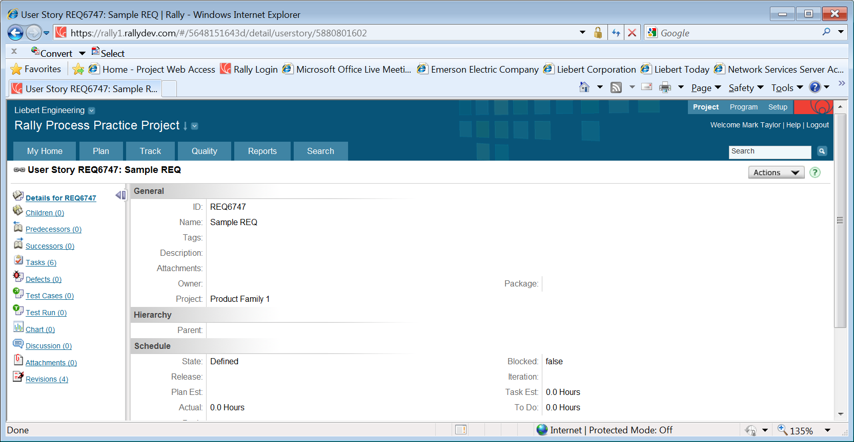

This will bring up the following view for a REQ.

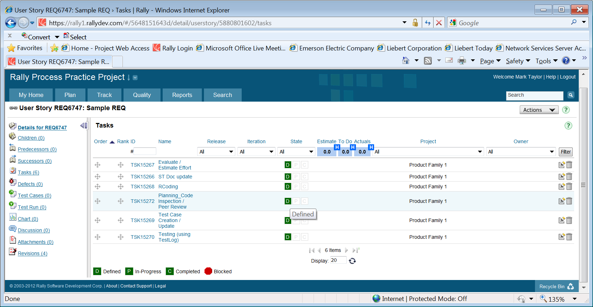

And the following view for a DEF.

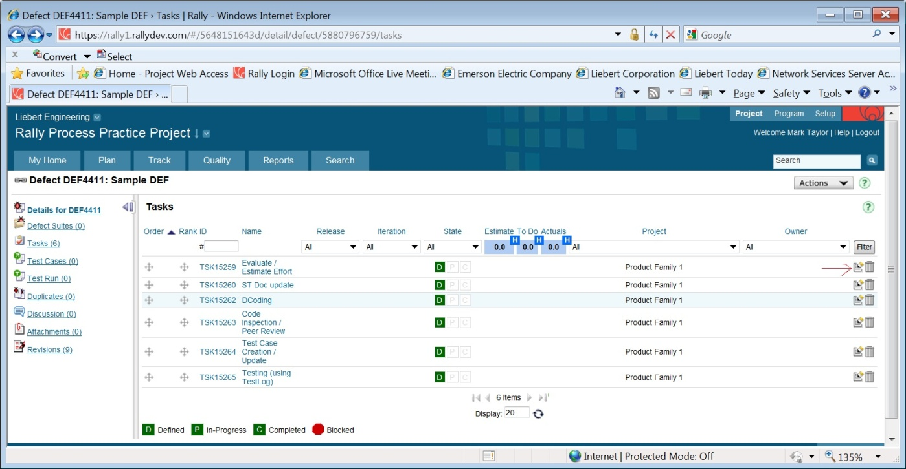

The pre-defined TSK names shown above are the standard naming conventions and must be used for all TSKs created under a given REQ / DEF. The naming conventions are required to facilitate project tracking. It would be permissible to add to the above names if further clarification for a given TSK is required, but the pre-defined names must be maintained.

If a given REQ requires more tasks (ex., multiple coding tasks are needed), the project lead or project manager may add them. However (for this example), the ‘RCoding’ or ‘DCoding’ keywords must be part of the name.

Note: the current release of this document does not define any keywords for hardware projects. Those keywords are yet to be defined and will be included in a future release of this document.

To describe the contents of a given TSK, perform the following steps.

Click on the ‘Edit’ icon, as shown by the red arrow in the above picture, to open it. The TSK will open in a new window.

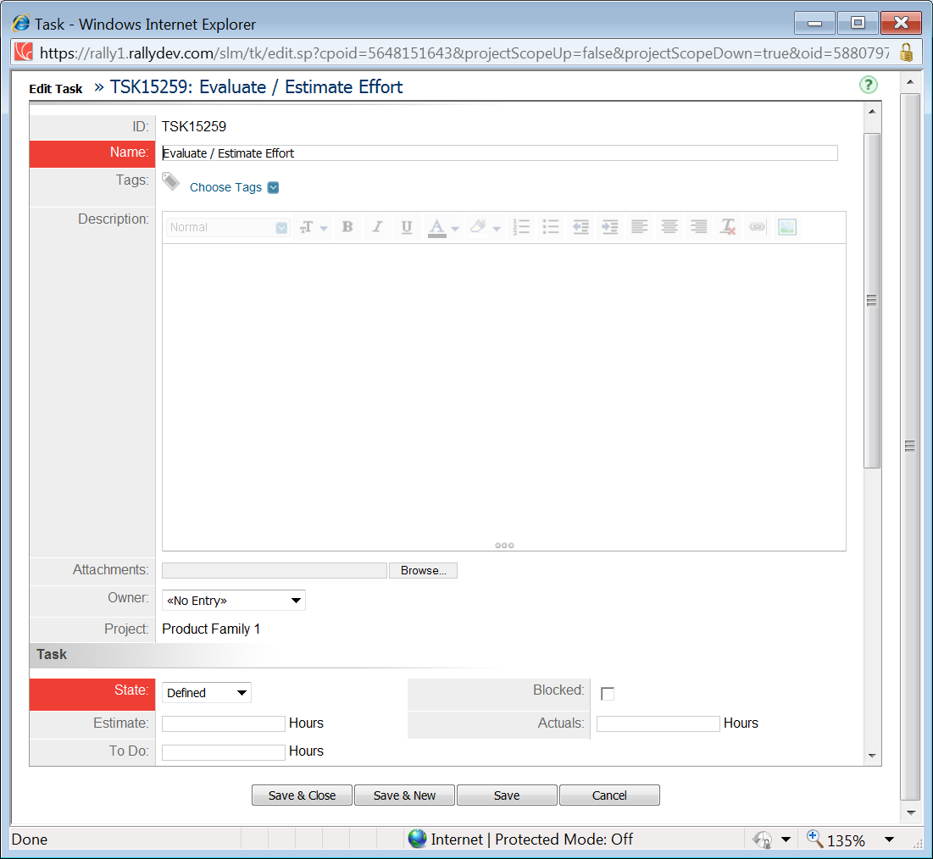

Only if required – Add to the ‘Name’ field any additional text needed for further clarification of the TSK

In the ‘Description’ field, write a detailed statement of the work needed to be performed to complete the TSK.

Assign the appropriate associate as the responsible ‘Owner’ of the TSK – the individual who will be completing the work item.

The project lead and / or the TSK owner will be responsible for entering the ‘Estimate’ for hours required to complete the given TSK.

Once all edits are complete, click on the ‘Save and Close’ button. Updates to each TSK will appear on the REQ’s ‘Task’ view.

**TSK Name Keyword Summary**

The following is a summary of the TSK naming conventions required for software projects:

Evaluate / Estimate Effort

ST Doc updates

RCoding, or DCoding

Code Inspection / Peer Review

Test Case Creation / Update

Testing (using TestLog)

1. **Records**

Not applicable

1. **Exhibits / Attachments**

Not applicable.

|  |  |  |
| --- | --- | --- |
| **REVISION** **HISTORY** | | |
| **Revision Level** | **Description Of Changes** |
| Add Revision Here | Add detailed description of change here. |
| 0 | Initial release |
|  |  |
|  |  |
|  |  |
|  |  |